

Zentity (Version 1.0)
Installation Instructions

May 2009

Contents
System Requirements 3
Supported Processor Architectures 3
Supported Operating Systems 3
Installation Requirements 3
Installation Requirements 3
User and Configuration Requirements 3
Unsupported Scenarios 3
Known Issues 3
Install Issues 3
Install Instructions 4
Uninstall Instructions 18
Repair Instructions 21
Notes 21
Support Information 21

System Requirements

Supported Processor Architectures
- x86 and x64.

Supported Operating Systems
- Microsoft Windows Server 2008 (x86 and x64)
- Microsoft Windows Vista SP1 (x86 and x64)

Installation Requirements

Installation Requirements
- Microsoft .Net Framework 3.5
- Supported Microsoft SQL Server
  - Microsoft SQL Server 2008 Enterprise Edition
  - Microsoft SQL Express 2008 with Advanced Services

User and Configuration Requirements
- Administrative privileges are automatically granted to the user installing Zentity.
- The selected Microsoft SQL Server instance must have “Windows Authentication” enabled.
- User running the installer must have ‘database creation’ permissions on the Microsoft SQL Server instance.

Unsupported Scenarios
- WOW64 (Windows on Windows 64-bit)

Known Issues

Install Issues
- After clicking Next on the End-User License Agreement screen there is a delay before the Feature screen appears.
WORKAROUND - This is normal behavior and may be caused by too many applications running simultaneously or due to a slow computer. It may help to close some of the running processes to speed up the system.
- Individual component selections are not working as expacted in installer
Workaround – Please choose to install all components.
- Installer displays message stating it could not create the database since a file called “Zentity_Data.mdf” already exists. This happens if the database was renamed after it was created.
WORKAROUND - Backup, delete and recreate the earlier database with a different name and re-run the installer.
- The installer does not proceed further after clicking “Next”.
Workaround- If installer does not appear to be proceeding, look for a new window on the task bar. An error may have occurred, and the error prompt might be out of focus.
- Repair option doesn’t work, if user tries to repair from control panel.
Workaround – Run the setup.exe again to repair the installed Zentity.
- Changing database file path for any Sql server setup (Core, OAI-PMH or Security) changes the same for all.
Workaround- use same location for all database file.
- Fields validation is not done for IIS setup dialog.

Install Instructions
- Double-click “Setup.exe”.
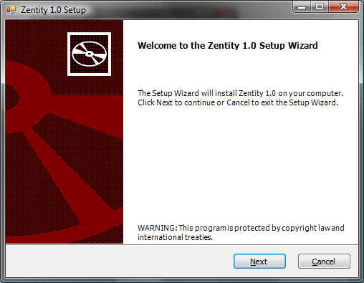
Figure 1 – Zentity Setup Wizard Welcome screen

- Click the Next button to start Zentity installation process.
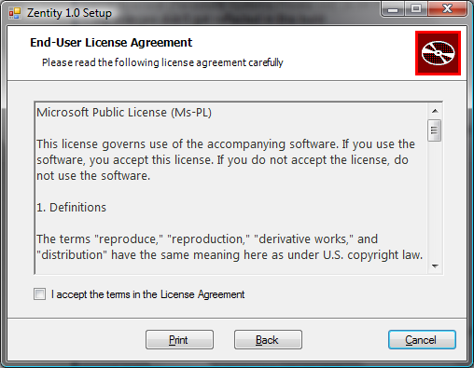
Figure 2 – End-User License Agreement screen: agreement not accepted

- Accept the License Agreement by checking the “I accept the terms in the License Agreement” check box. The Next button will become visible as shown in figure 3 below. Click the Next button to proceed.
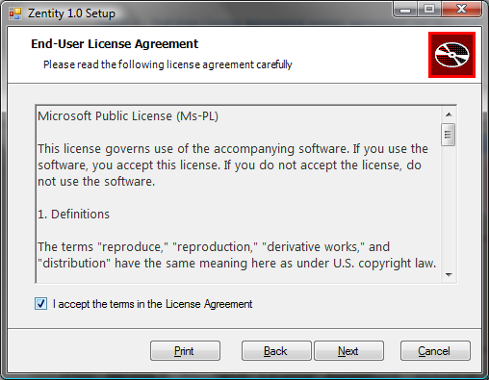
Figure 3 – End-User License Agreement screen: agreement accepted

- If any software prerequisites are not met, a screen similar to the one in figure 4 will be displayed containing details about the software prerequisites that were not met.

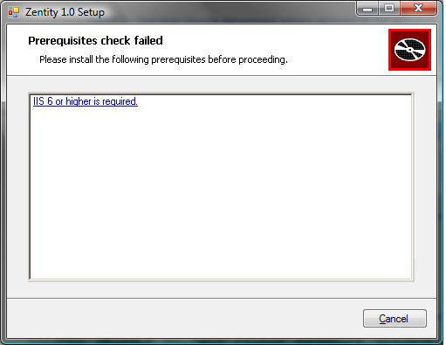
Figure 4 – Prerequisite check failed screen

- Once all software prerequisites are met, installation will continue to the “Custom Setup” screen.
  - Click the Next button to proceed after making any changes desired.

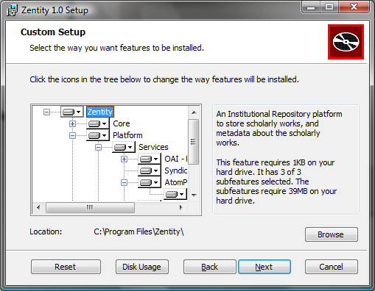
Figure 5 – Custom Setup screen

- SQL Server Setup
Zentity needs to create three databases; one for storing the repository information, one for storing some internal information related to OAI-PMH and one for string security data.
The first setup is for the database storing the repository information.
  - A database named “Zentity” will be created on the specified instance.

  - Note on the file paths: Although the installer suggests a path, please confirm that the path is valid or click on “Default” button to fetch the default data file path of the specified SQL Server instance. The file paths refer to the computer which has the target Microsoft SQL Server instance.
    - If the system on which the installer is being run is different from the one that has the Microsoft SQL Server instance you’ll need to ensure that the file paths are valid.
    - Ensure that the drive/partition on which the folder is located has adequate disk space to allow for database growth.

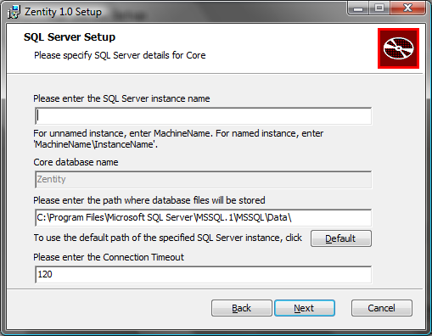
Figure 6 – Microsoft SQL Server Setup screen

  - Enter the SQL Server instance name for for Core
    - For unnamed instance, enter ‘MachineName’.
    - For named instance enter ‘MachineName\InstanceName’
    - You must specify an existing Microsoft SQL Server Instance.
    - You must have access to the Microsoft SQL Server Instance.
    - You must have database creation permissions on the Microsoft SQL Server Instance.
    - You must be a member of the following roles
      - serveradmin
If ANY of the above requirements is not met, the installer will display an error message.
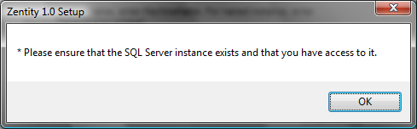
Figure 7 – SQL Server permissions error dialog

  - Connection Timeout refers to the duration in seconds after which database connections will timeout.

- When all the information has been filled in click the Next button to proceed.
  - The installer checks to see whether a database with the name “Zentity” exists on the target SQL Server instance. This is to prevent any accidental data loss that may occur if the existing database is overwritten. If a database named “Zentity” already exists on the target SQL Server instance, you will be provided with an error message.
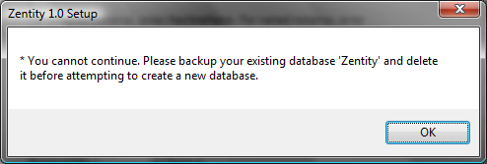
Figure 8 – Pre-existing database error for “Zentity” database dialog
  - If your user does not have access to an existing “Zentity” database, then the installer will fail to provide the error above.

  - Sample filled-in SQL Server Setup screen for “Zentity” database.
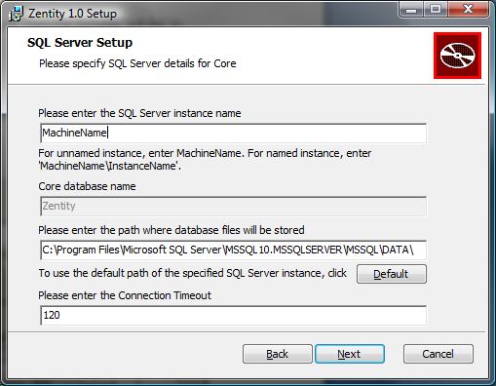
Figure 9 – Sample filled SQL Server Setup screen for “Zentity” database
  - Files that are uploaded to Zentity are stored in a file system folder. Uploaded files will be stored at ‘ZentityFiles” folder.
    - Ensure that there is adequate space on the drive/partition where you want to store your uploaded files.
    - This folder and path refers to the computer that has the target Microsoft SQL Server instance in the previous step.

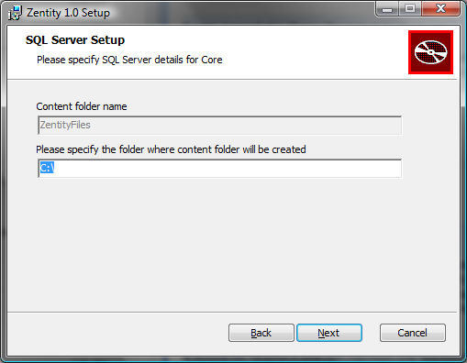
Figure 10 – Content store screen
    - Please click the Next button to proceed.

- The second setup is for the database storing some internal information related to OAI-PMH.

  - This dialog by default takes the values that were specified in Core SQL Server; you may specify a different Microsoft SQL Server instance.

  - The installer will create a database called “ZentityPlatform” on the specified SQL Server instance. Also, the previous notes about the file paths and permissions are applicable here too.

  - For the other fields, please follow the same instructions as mentioned in Installation Step 7.

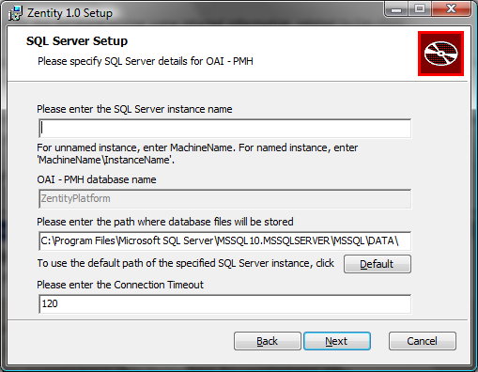
Figure 11 –Server Setup screen for Zentity Platform
- When all information is complete, click the Next button to proceed.
  - The installer checks to see whether a database with the name “ZentityPlatform” exists on the target SQL Server instance. This is to prevent any accidental data loss that may occur if the existing database is overwritten. If a database named “ZentityPlatform” already exists on the target SQL Server instance, you will be provided with an error message.
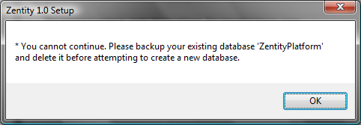
Figure 12 – Pre-existing database error for “ZentityPlatform” database dialog
  - If user does not have access to an existing “ZentityPlatform” database, then the installer will fail to provide the warning above.

  - Sample filled-in SQL Server Setup screen for “ZentityPlatform” database.

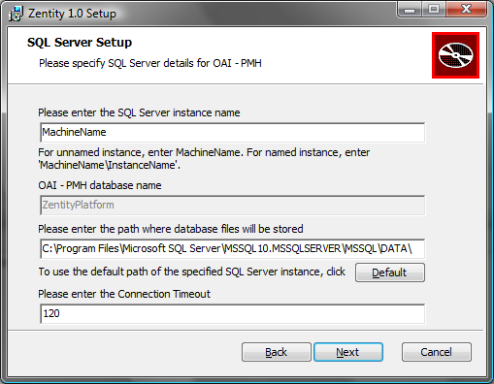
Figure 13 – Sample filled-in SQL Server Setup screen for “ZentityPlatform” database

- The third setup is for the database storing security information.

  - This dialog by default takes the values that were specified in Core SQL Server; you may specify a different Microsoft SQL Server instance.

  - The installer will create a database called “ZentityAuthentication” on the specified SQL Server instance. Also, the previous notes about the file paths and permissions are applicable here too.

  - For the other fields, please follow the same instructions as mentioned in Installation Step 7.

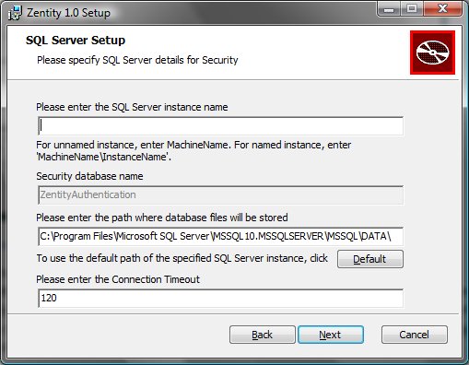
Figure 14 –SQL Server Setup screen for Zentity Authentication
- When all information is complete, click the Next button to proceed.
  - The installer checks to see whether a database with the name “ZentityAuthentication” exists on the target SQL Server instance. This is to prevent any accidental data loss that may occur if the existing database is overwritten. If a database named “ZentityAuthentication” already exists on the target SQL Server instance, you will be provided with an error message.
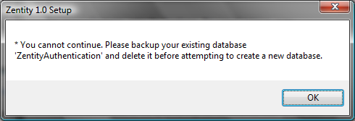
Figure 15 – Pre-existing database error for “ZentityAuthentication” database dialog
  - If user does not have access to an existing “ZentityAuthentication” database, then the installer will fail to provide the warning above.

  - Sample filled-in SQL Server Setup screen for “ZentityAuthentication” database.

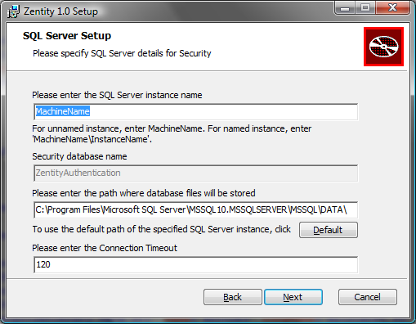
Figure 16 – Sample filled-in SQL Server Setup screen for “ZentityAuthentication” database

- IIS Setup
Zentity provides configuration of virtual directory names for 2 web applications: Default Web UI and Services.
These settings can be modified if required or you may proceed with the default settings.

  - Web Site Name: You may specify any desired name for the repository website.

  - Web Site Port: This is the port number on which the Web UI/Services will run.

    - Ensure that the specified port number is not already in use.
    - Ensure that the port number consists of only numbers.

  - Virtual Directory Name for Services: This is the name of the virtual directory for the Services.
    - Ensure that the name consists of only the characters a-z and A-Z.

  - Virtual Directory Name for Web UI: This is the name of the virtual directory for the Web UI.
    - Ensure that the name consists of only the characters a-z and A-Z.
  - Connection Timeout refers to the duration in secs after which IIS connections will timeout.

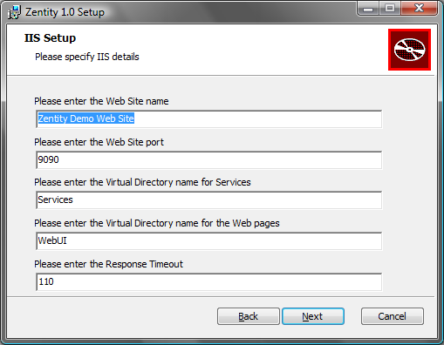
Figure 17 – IIS Setup screen
  - Please click the Next button to proceed.
- IIS Application Pool Setup
  - All the virtual directories that are created as part of a Zentity installation run under a specific Application Pool.
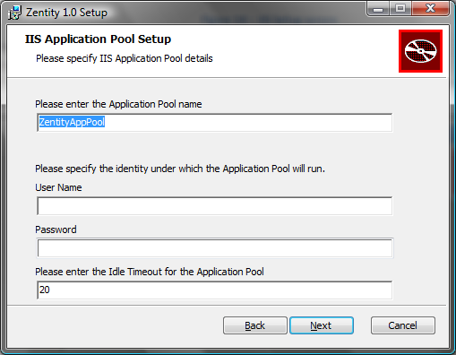
Figure 18 – IIS Application Pool Setup screen
  - Enter valid identity under which the Zentity Application Pool will run.
  - The User Name should be in the form: DomainName\UserName.

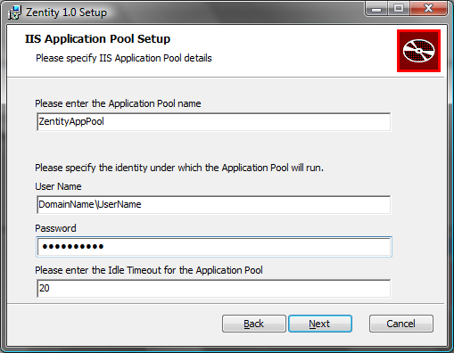
Figure 19– Sample filled-in IIS Application Pool Setup screen

- Ready to Install Zentity Beta 2 Release
  - Click the Install button.

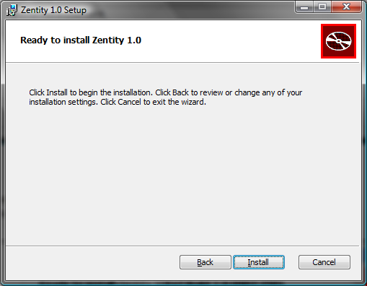
Figure 20 – IIS Setup screen

  - Setup will continue with the installation.

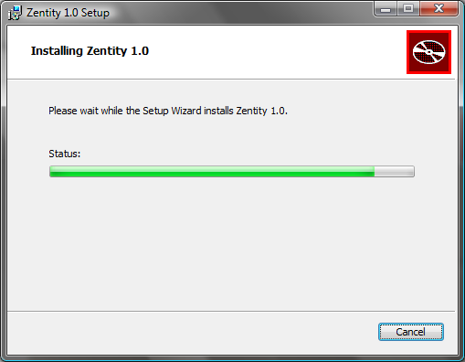
Figure 21 – Install in progress screen

- When complete, click on Finish button to close the setup wizard.
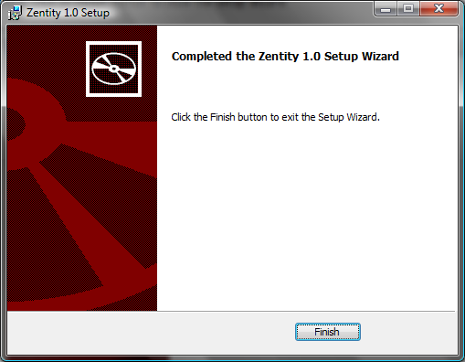
Figure 22 – Installation Completed screen

Uninstall Instructions
- Double-click “Setup.exe”.
- Click “Next” button to continue or “Cancel” to cancel the Setup. 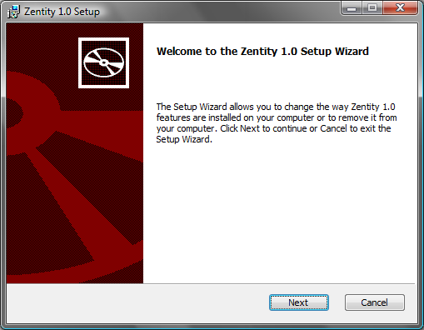
Figure 23 – Installation welcome screen
- Click on “Remove” button to uninstall the Zentity or you may click on “Repair” button to repair missing Dlls or Zenity related corrupted files. 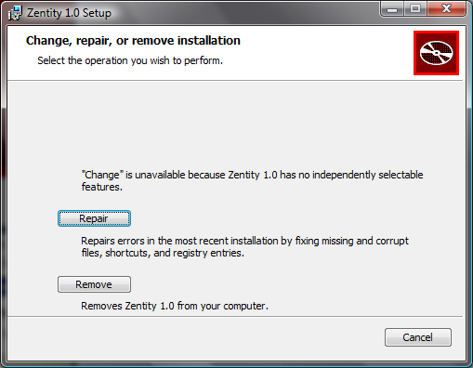
Figure 24 – Repair/Remove option screen
- Click again on “Remove” button again to uninstall “Zentity”.
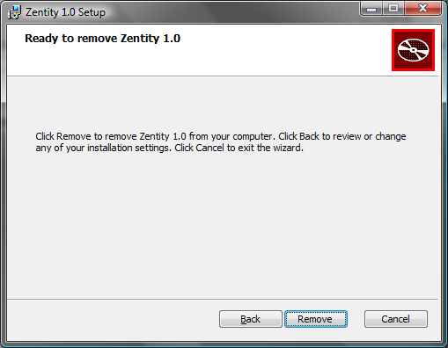
Figure 25 – Remove screen
- Uninstall starts.
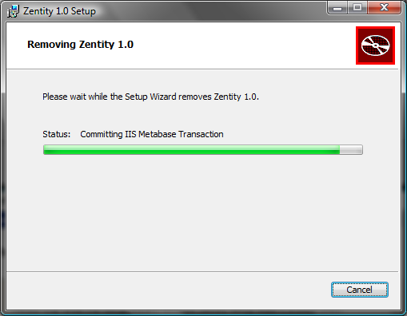
Figure 26 – UnInstallation in progress screen
- Click on “Finish” button when uninstallation completes.
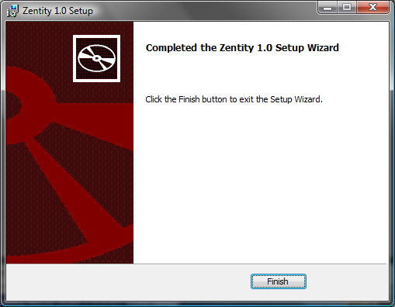
Figure 27 – Uninstallation Completed screen

Repair Instructions
- Double-click “Setup.exe”.
- Click “Repair” on the second screen and follow the instructions.

Notes
- A log file called “Install.log” is created every time the installer is run. Please note that on subsequent runs the same log file is overwritten. If you receive the installer through a CD/DVD, you may have to copy the files to a hard disk before you can launch the installation.
- The databases created by the installer are not removed during un-install. Nor are they repaired when the installer is run with the “Repair” option. This behavior is by design to prevent any accidental data loss.
- This version of the installer does not create any shortcuts for OAI-PMH and OAI-ORE services. Once the install is complete successfully, please use the following URLs to access the Web UI/Services. Note that <Web Site Port Number>, <WebUI Virtual Directory>, and <Services Virtual Directory> refer to the ones specified in the installer.
  - Web UI – localhost:<Web Site Port Number>/<WebUI Virtual Directory>/Default.aspx
  - Syndication Service – localhost:<Web Site Port Number>/Syndication/Syndication.ashx/help
  - OAI – PMH Service – http//localhost:<Web Site Port Number>/<Services Virtual Directory>/OaiPmhService.ashx
  - AtomPub Service – http://localhost:<Web Site Port Number>/AtomPub/AtomPub.ashx/ServiceDocument
  - SWORD Service – http://localhost:<Web Site Port Number>/AtomPub/sword/Sword.ashx/ServiceDocument
  - OAI – ORE Service – http://localhost:<Web Site Port Number>/OaiOre/Ore.ashx
- Zentity provides default admin user with username as “administrator” and password “admin@123”.
It is advisable to change the admin password after completion of installation.

Support Information
- For any issues please contact irplat@microsoft.com

