Use of gestures in a multi-device environment

Gerard Oleksik
Rachel Jones
Natasa Milic-Frayling

6 May, 2010

Technical Report
MSR-TR-2010

Microsoft Research
Microsoft Corporation
One Microsoft Way
Redmond, WA 98052

Use of gestures in a multi-device environment

ABSTRACT
We report a case-study of an evolving meeting space based on a 6-month observation of a multi-device meeting environment. Each meeting member had his own tablet PC and the meeting group used a large vertical display to view presentations, meeting notes, sketches, and other documents. After our first round of observations, a large tabletop computer was introduced. Subsequent observations enabled us to assess the impact of the device upon the meeting activity. We observed a marked increase in the incidence and variety of gestures. The aim of our analysis was to identify the factors that contributed to the observed use of gestures and understand the meaning and function of these gestures. We focus on the role of gesture in directing attention to the content on a single device and heterogeneous content across multiple devices.

contents
1. INTRODUCTION
2. RELATED RESEARCH
2.1 Technology, user practice and gesture
2.2. Gesture
Purpose of gesture
Gesture in face-to-face meetings
2.3 Inscription
2.4 Section summary
3. METHOD
3.1 Investigation technique
3.2 Environment
4. FINDINGS
4.1 Gesturing behaviors across the meeting setups
4.2 Multiple devices and gesture
Replication of content
4.3 Gesture across devices and binding of content
Binding on single devices
5. DESIGN GUIDELINES
5.1 Align content and interpretation
5.2 Support inscription
5.3 Distinguishing interpretative gesture from input gesture
6. CONCLUSIONS AND FUTURE WORK

- INTRODUCTION
A central goal of research efforts in CSCW and HCI is to expose and understand the relationships between technologies and human behaviour. By exploring technology use in everyday environments and workplaces, we deepen our understandings of how technology can support user practice as well as change, augment or disrupt it, providing insights for the next generations of technology.
From the earliest days of these disciplines a significant body of research has grown exploring the meeting space, the technologies which support it and behaviour involved in collaborative activities. As the technologies in use within meetings broaden in scope and number, understanding how these objects are used serially and in conjunction, and the impact of this on user behaviour, becomes of critical importance to the design of meeting spaces, devices, and the infrastructure that enable technologies to work well together.
We report a case-study of an evolving meeting space based on 6-months of observation. Observations were conducted within a multi-device environment where each meeting member had his or her own tablet PC and the meeting group used a large vertical display to view presentations, ongoing meeting notes, sketches, and other documents. After our first round of observation, a large tabletop computer was introduced, and subsequent observations enabled us to assess the impact of the device upon the meeting activity.
On introduction of the tabletop computer, we observed a marked increase in the incidence and variety of gestures, and we orientate analysis towards understanding the factors which contributed to this increase and also unpicking the meaning and function of these gestures. We focus upon the role of gesture in directing attention to single devices, and across heterogeneous content on multiple devices. Further, we reflect upon the semantic meaning bound into gesture and explore how and why gesture changes as new devices, and new orientations of devices, are introduced into the meeting space.
Our analysis identifies a series of binding gestures, orders of gesture currently not recognised within HCI, CSCW or gesture studies. Binding gestures are part of the gestural behaviour by which participants associate content across and upon single devices. Such gestures were observed throughout the different meeting setups, however they manifested in increasingly fluid ways when the tabletop computer was involved.
In the following section, we reflect on the related research, going onto describe in detail the study environment and the data collected from our in-situ observations. We then discuss the main findings of the study and outline the design implications for creative supportive multi-device environments.
- RELATED RESEARCH
The literature is divided into two sections. To contextualise and ground our findings, we first review research exploring the impact of technology on user’s attention to electronic content, and interaction with other users, in collaborative and meeting settings. This highlights the influence of input method, orientation, and proximity to content on user’s attention to that content.
We then broaden the literature base to consider a wider sweep of work within CSCW and gesture studies, exploring in more depth the meaning and function of different types of gesture within collaborative environments. Together, this research provides insight into the technological and spatial properties that give rise to gesture and also spotlight the broader meanings and function of gesture in different circumstances.
2.1 Technology, user practice and gesture
The meeting space is a place where humans interact with artefacts, technologies and each other, and the nature of these interactions has been studied extensively. Providing a review of a decade’s work in the area, Olsen and Olsen [2004] draws out the importance of spatiality and co-presence to establishing collaboration and ‘common ground’ within meeting spaces. Common ground is the knowledge participants have in common and know that they have in common, which helps to form the basis of communication. Comparing collocated and distributed teams, she charts the ways in which common ground is established in collocated environments through the use of deictic gesture and glance, body language, posture, facial expression, and argues the subtle interplay of these factors cannot always be well translated to distributed collaborative environments. Thus spatiality plays a critical role in effective collaboration.
Evaluation of large displays, interactive tabletops and multi-device environments also reinforces the importance of spatiality to collaborative work and illustrates how spatiality and proximity impact upon technology use and collaborative activity. Hawkey et al. (2005) spotlight the impact of distance on co-located collaboration around large wall displays by asking paired participants to collaborate on tasks at various distances from large displays and from each other. When two participants collaborated near the wall display, the authors found collaboration to be most efficient, however when one participant was situated 10 feet from the display (the optimal recommended viewing distance from such a display) and given a synchronised tablet to interact with the display, the authors report communication and collaboration broke down. This was due in part to the input method used for making annotations and directing attention on the screen. When participants were close to the display, the screen acted as a shared resource to which both could easily point and gesture when discussing the task. When focusing on different displays (one on the wall monitor, one on the tablet PC) there was no shared focal point and, therefore, the communication degraded. ‘If users divide their attention between the two displays, their individual and collaborative interactions may suffer’.
Ha et al. (2006) established a relationship between method of input to tabletop computers and the communication and gesturing around content. Setting participants tasks on interactive tabletops to perform with mouse, stylus or touch, the authors found that stylus and touch conditions stimulated more gesturing. Furthermore with the mouse was used participants tended to sit back further in their seats and be less active. While participants used mouse gestures to indicate part of the display during collaboration, overall the authors reported more gesturing when the tasks were conducted without the mouse. The study made a distinction between direct input and gestures (with touch and stylus) and indirect (such as pointing across distance and gesturing with the mouse cursor to indicate areas of the screen).
Further work has exposed gesture use in relation to interactive surface computers, in particular to multi-touch table-top computers. Roger and Lindley’s (2004) comparison of group interaction around vertical and tabletop interactive displays show an increased use of gestures around tabletop displays, especially so in the horizontal plane. In other work, Rogers et al. (2004) discovered a slew of 'finger acts' which participants made whilst collaborating on an interactive tabletop. While many of these acts were part of touch input to the system (such as rotating an image to a person to encourage participation), they also included pointing gestures which did not make contact with the interactive surface.
Research by Piper and Hollan (2008) also report that the specific affordances of the tabletop computer directly contribute to the increased use of gestures. They report on the study that involved communication between a deaf patient and a doctor, facilitated by a shared tabletop display with voice recognition software. The software translated the doctor’s speech to text and displayed it on the table along with other relevant information. Persisting the doctor’s speech and making it available to the deaf patient meant that a sign language interpreter was not required during consultations. This condition freed both the doctor and the patient to use more gesturing during the consultation to elaborate points or make key iconic gestures. Both of them pointed to information on the tabletop to indicate locations on a map and reference previously translated speech.
The above literature illustrates that:
- Spatiality plays a critical role in collaborative activity
- The method of input and user proximity to content may increase gesturing to content
- The horizontal plane appears to encourage more gesture
- While partly related to the affordances of the technology, user practice around the technology is a key element in the gesturing to content.
Having established circumstances which give rise to gesture, we now review literature which deals with gesture itself.

2.2 Gesture
Within the significant body of HCI and CSCW research dedicated to the study of gesture lies a fault line. This falls between the application of gesture as a rich input method [references], and the study of gesture as an inherent and richly communicative aspect of human interaction [references]. The former work flows from technological advancement related to interactive tabletops, tangible computing, computer vision and multi-touch, all of which widen the scope of naturalistic input methods. The second body of work explores the expressive role of gesture within human interaction, gesture’s communicative capacities and function in aligning activities and awareness in collaborative work. It is this latter body of research which we concentrate on here.
2.2.1 Purpose of Gestures
While it is widely accepted that gestures have important communicative meaning, there is a debate as to why gestures are made: are they to benefit the person making the gesture or the addressee? Hadar and Butterworth (1997) argue that gestures mainly help facilitate lexical retrieval and thus benefit the speaker rather than the listener. Other work, however, emphasizes the strongly communicative value of gesture and its role in social interaction (Goodwin, 2003). Here we discuss several specific contexts in which roles of gestures have been studied in more details.
2.2.2 Gestures and Spoken Language
Gestures have been recognized by Goodwin (2003) as a key aspect of information exchange that, in conjunction with speech and contextual elements, forms a unified communicative unit between speaker and listener.
According to McNeill (1992) one can discern between 5 broad roles that gestures play: (1) iconic gestures that ‘bear a close formal relationship to the semantic content of the speech’ and thus provide a visual back up for what is being said, (2) metaphoric gestures that are ‘pictorial, but the pictorial content presents an abstract idea rather and a concrete object of event’, (3) beat gestures that are rhythmic accompaniments to speech and may emphasize the importance of certain words, (4) cohesive gestures which bind together what is being said, and (5) deictics or pointing gestures that directs listeners’ attention to specific objects as they are mentioned.
2.2.3 Gestures in Face-to-face Meetings
Mathilde et al. (1995) explored the use of gesture in face-to-face meetings among 10 design teams and isolated 4 different types of gesture: (1) kinetic gestures as body movements that execute all or part of an action, (2) spatial gestures as movements that indicate distance or location or size, (3) point gestures, normally made with fingers to point to a person, an object or a place thus denoting an attitude, attribute, affect, direction, or location, and (4) other gestures that have a purpose but do not fall into the above categories, including those that merely serve to emphasize parts of a sentence or to attract attention.
In addition to the classification of individual gestures, Methilde et al. (1995) point out that users often make multiple gestures in sequence. Such gestures are meant to work in concert with each other rather than independently. Mathilde et al. (1995) describe four gesture sequences found in observed meeting situations: (1) walkthrough sequence comprising kinetic gestures that describe an interaction between the user and a designed product, (2) list sequence where the user indicates numerical sequence on his or her fingers while the discussion follows a list of items, (3) contrast sequence of point gestures that emphasize the contrast between two ideas or options by the user first pointing to one hand and then the other, and (4) emphasis sequence of gestures to indicate the structure of the sentence being uttered and similar aspects.
Studies of interactions during collocated collaborative sessions highlight the inherent role that gestures play as a rich communicative aspect of human interaction. Kraut et al. (2003) highlight the importance of gesture in establishing and maintaining situation awareness. Mathilde et al. (1995) establish that gesturing is an integral part of 3 broad categories of group activities: design activities, management activities, and conversation regulation activities.

2.3 Inscription
Inscription is an activity closely related to gesture. The term refers to persistent marks or images made within a work environment for the purposes of communication and sense making (Cortina et al. 2004, Goodwin, 2003. Streeck and Kallmeyer, 2004).
Cortina et al. (2004) reports on the importance of inscription in the support of mathematical learning and problem solving. The authors describe how the inscription of a mathematical problem within a classroom, through the direction of the teacher and class wide discussion, becomes a representation of the problem area and an active scaffold for collective reasoning and attention. This process involves the teacher’s addition of student comments to the inscription to capture the direction and development of thought.
From the work by Goodwin (2003) we learn about the importance of inscriptions placed in close proximity of the focal point, in this case an archaeological artefact that cannot be physically moved. Goodwin describes how students and supervisors make sense of the dig site by creating inscriptions in the dirt around archaeological features which must not be disturbed: “the inscription creates a special kind of luminal representation. Unlike what happens when the pattern is further transduced, say into a map, here the representation and the entity being represented co-exist within the same perceptual field, and thus remain in a state where each be used to judge the other”. This highlights the importance of the appearance of the inscription within the same ‘perceptual field’ as the feature, which enables the two to be juxtaposed. That is the interpretative action of inscription exists within the same visual field as the content which inspired it.
Research shows a fine interplay between inscriptions and gestures. Streeck and Kallmever (2004) state that because of their persistent nature “inscriptions can become the targets or components of further symbolic actions” including physical gestures. Goodwin (2003) points out that inscriptions made around archaeological features become an immediate resource for speech and gesture. These gestures enter the dialogue that unfolds around inscriptions, enabling archaeologists to make directed suggestion and comments. In the work by Cortina et al. (2004), we see how gestures around inscriptions function as key elements of collaborative learning in the classroom, serving to direct attention and illustrate mathematical relationships. In fact, inscriptions, gestures, and speech seem to be tightly intertwined. Streeck and Kallmeyer (2004) argues that inscriptions are part of the mise-en-scene of interaction and become ‘interfaces – mediating structures’ between people during face to face interaction. To paraphrase Streeck’s and Kallmeyer’s (2004) assertion [14], the social interactions can be seen as a ‘vociferous process’, hungrily consuming inscription, speech and gesture, and weaving them into meaning.

3.4 Section summary
The literature indicates the important role which gesture plays in collaborative work, spotlighting how it is used in directing attention, illustrating concepts, explicating content, establishing common ground. The literature also highlights the critical importance of the spatial in collaborative work, underlining the influence of technology, orientation, proximity and input method on collocated collaboration and the frequency and type of gestures users employ.
In our study, we observe the introduction of a new technology to a meeting environment and assess its impact upon user gesture and the interpretative work which users perform during meetings in a multi-device environment. The following section describes how we went about this.
3 METHOD
Over the period of 5 months, we observed meeting sessions at the university research centre that focuses on design and investigation of new materials. The environment involves state-of-the-art nano-photonic technologies that are used to configure and analyze characteristics of materials arising from various molecular structures and properties. Researchers use high-precision scientific instruments to collect measurements and specific software packages to visualize and analyze experimental data. Their practices involve various forms of sense-making by individual and group work.

3.1 Investigation technique
Data Collection. Analyses presented in this paper are based on the data collected over 10 hours of in-situ observations at the centre. More precisely, we observed 7 separate meetings, involving staff from two research groups. All the meetings were held in the same physical location that changed over time to include a surface computing technology. This enabled us to observe a range of participants’ behaviors over time in three configurations of supporting hardware, i.e., one without and two with the surface computer (Figure 3). The data collected in the meeting space was part of a wider engagement with the research centre to understand the entire work environment. This background provided us a firm grounding work practices undertaken by participants, which provided a significant vantage point from which to approach the interpretation of meeting behaviours. We began with observations of 3 meetings within the first set up where attendees sat around the research leader’s desk with their tablet computers and used a relatively large (dimensions) vertical monitor to display content for the group viewing. The next round of observations involved 3 meetings in the second set up where meeting attendees sat around the surface computer next to the leader’s desk. Surface computer and the vertical monitor on the leader’s desk were used for the group viewing of the meeting material. The final observations were made in the third set up where the surface computer was integrated into the research leader’s and put the two display into closer proximity. All the meetings were video recorded.
Data Analysis. We started our analyses by selecting two videos, one from the first and the second set up. We analyzed them in detail, focusing on the participants interactions among themselves and with the technology. We described each meeting interaction and identified the aspects that are distinctly different in the two settings and those that emerged as sub-optimally supported in either of them. They spread across three phenomena that were interwoven: (1) the use of gestures, (2) the use of inscriptions, and (3) the use of different computing devices to direct participants’ attention to specific content as they exchange of information and engage in sense-making. With this focus we then analyzed the remaining videos.

3.2 Environment
Organization and Practices. Observations were conducted at an advanced nanotechnology learning environment and focused on the space used for regular group meetings.
Meetings are held in the research leader’s office, and are attended by the research leader, post doctorate staff (post docs), and doctoral (PhD) students from two closely related research groups. Meetings occurred on a bi-weekly basis and their purposes are threefold: to present progress to the research leader and other group members, to discuss and interpret the findings within the meeting context, and to set next steps in terms of experiments or different approaches to pursue.
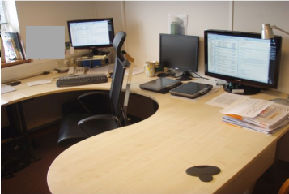 | 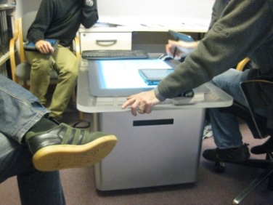 | 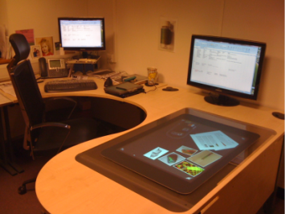
Set up 1. Meeting attendees sit around the research leader’s desk with a vertical monitor connected to the local area network. Participants bring to the meeting tablet computers that they regularly use in their everyday work. | Set up 2. Meeting attendees sit around the surface computer next to the leader’s desk. The vertical monitor on the desk is also used, as well as the tablet computers brought in by the individuals. | Set up 3. The surface computer is integrated into the research leader’s desk. Both the vertical surface and the tablet PCs are used in the meetings.
Figure 1 Different meeting configurations
A typical meeting would involve post docs and PhD students presenting overviews of their recent work in the form of summaries. These are documents created using MS PowerPoint slides containing graphs and data generated during experiments. Such are visual representations of experimental measurements and statistical analyses produced using specialized tools. The slides also use explanatory descriptions and information from electronic lab books that was recorded while conducting experiments. Lab books are implemented using MS OneNote software. The same software is used to take notes during meetings. While textual data is included, the summaries are distinctly graphical in nature.
The format of the meetings stays more or less the same. Students present their findings in turn, describing the graphs and raising questions and concerns with the research leader. These are projected onto the large display that everyone can see. During the presentations the research leader typically asks questions about the collected experimental data. This naturally leads to in depth discussions of the results and often requires from the student to access additional data about the experiments. This is typically facilitated by the student’s tablet PC. Throughout the meeting, the research leader takes notes on his tablet on behalf of the group, and produces sketches to illustrate solutions to problems, explain concepts or describe experimental setups. The notes include outlines of further explorations and specific tasks for the students. Thus they serve as records of the meetings and resources for further work.
These group meeting practices are meant to facilitate learning and support innovative and ground-breaking research through collaborative work, as described by the research leader’s own words: “We sit round this table just figuring out what on earth is going on here [within the presented summaries].” They are essential for the success of individual students and the research group as a whole. Thus, the research leader continues to optimize the meeting space to increase their productivity and effectiveness. This involves experimentation with new hardware and software technologies and various spatial configurations of the meeting place.

3.3 Study Participants.
Table 1 Study participants
Participant | Role | Meeting setup
John | Research leader | All
Ali | Post doc | 1
Steven | Post doc | 2,3
Darren | Visiting student | 1
Josh | Visiting student | 2
Paul | 1st Year PhD | 1
Anthony | 1st year PhD | 2,3
James | 2nd year PhD | 1
Mike | 2nd year PhD | 1
George | 2nd year PhD | 2,3
Charles | 3rd year PhD | 1
Keith | 3rd year PhD | 1
Ralph | 3rd year PhD | 1

In total, 13 participants were involved in the study. Table 1 provides anonymised details of the participants, their roles and the meeting setups in which they were observed.
In the following section we describe several group encounters in three meeting setups that we introduced above. We provide details of the activities and interactions that unfold during the meetings involving researcher’s summaries, raising questions, discussing implications, exploring solutions and setting next steps. Our aim is to understand how these activities are supported across the different setups. Specifically, we shall explore the use of gesture and inscriptions, the inter-relationship between different displays and types of information artefacts, and the focal points of participants’ attention. We expect this will provide insights into the principles that underpin effective collaborative environments and practical design recommendation for their implementation.

- FINDINGS
In this section we discuss the core insights gained from the study. This discussion considers how content is attended to, talked about and interpreted within the group. We also focus upon the different devices used within the meeting, the inter-relationships between them, and how user experience is negatively impacted when these inter-relationships breakdown.
A central focus of the analysis falls upon the form and function of gestures within each setup, the semantic meaning of these gestures and how they are used to direct attention to, and across, devices.
We begin by exploring the broad changes in gestural behaviour between the different setups and issues surrounding gesture and content replication within meetings. We then move on to introduce the notion of binding gestures as we explore the gestural language used to associate heterogeneous content upon and across devices. We conclude with emerging design recommendations.
4.1 Gesturing behaviours across the meeting setups
As expected from previous research (Mathilde et al. 1995), we found deictic gestures were used extensively across all meeting setups, and fell into two main types: indirect (when the user indicates a part of the screen the mouse cursor) and direct (i.e. when the user points to the artefact) (Ha et al. 2006).
Participants exhibited the highest degree of indirect deictic gestures before the tabletop computer was introduced, in meeting setup 1. Here the research leader (John), frequently used indirect mouse gestures to indicate the areas of summary presentations he was talking about, and on occasions, other participants would do so also. Furthermore, John also performed kinetic gestures over meeting content using the mouse, for example, sweeping over parts of the screen to describe concepts or indicate the movement of particles within and experiment.
A high proportion of the direct deictic gestures in setup 1 were made over a distance, due to participants’ position in relation to the shared display. Participants sitting closer to the display were able to directly point to parts of the screen to indicate what they were referring to (see Fig. 2).
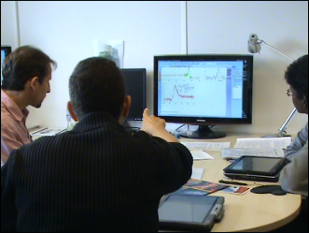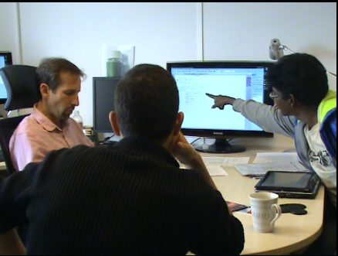
Figure 2 Distant and direct deictic gesture
In meeting setups 2 and 3, meeting presentations were displayed on the tabletop computer, and gesturing to the content was quite markedly different, with high incidence of direct deictic gesture, from the meeting leader and other meeting attendees. The gestural language to meeting content also increased in complexity to encompass complex, two handed gestural walkthroughs and physical tracing over content to describe particular concepts, experimental setup or physical process (Fig. 3).

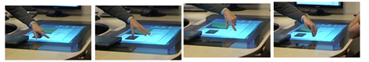
Figure 3 Example of gestural walkthrough on Surface
Across all meeting setups, the meeting leader also used direct deictic gestures and gestural walkthroughs to his tablet, to help elaborate and clarify the meaning of sketches he made on the device.
4.2 Multiple devices and gesture
The meeting space contained heterogeneous content, displayed on heterogeneous devices, and we explored the management of content across different devices, focusing on the role played by gesture in directing user attention to, and interpretation of, content.
4.2.1 Replication of content
As indicated earlier, throughout the meeting, the meeting leader took notes on behalf of the group. These inscriptions often consisted of sketches which depicted experimental setups, graphs, or physical processes, and in order to make these visible to the group, the meeting leader would at times display them on the shared monitor. While this action increased the visibility of content, it had knock-on effects for certain interpretative gestures used within meetings. This relationship between replicated content and gesture is explored in the following two meeting scenarios.
Activity Scenario1. Set up 1. Peter and John are in a one-to-one meeting, discussing a series of graphs which Peter generated in the lab and laid out on a PowerPoint slide for the meeting. Paul had been puzzled about some of the graph output. John is explaining what the graph lines depict and commenting on their shapes. In order to elaborate further, John switches the shared display from the graphs they have been discussing to the contents of his tablet, and, using his stylus, begins to make an explanatory sketch on his tablet. The sketch, now also displayed on the desk monitor, illustrate the difference between an electronic and thermal response in the experiment and how to recognise them.
Paul begins by viewing John’s sketching on the monitor. John talks about the sketch he is making while producing it, and after several second, begins to gesture to specific parts of the graph with his stylus, explaining what they represent. At this point, Paul switches his attention from the desk monitor displaying the sketch to the tablet, and does so for the rest of the discussion, as Jeremy continues to sketch and intersperse with explanatory gestures.
We can extract several important points from this example scenario. Firstly, we note that in creating a sketch to help explain the contents of Paul’s summary slides, John is using his tablet as an inscription device. That is, while the inscription is an interpretative act in explaining Paul’s graphs, it simultaneously becomes a resource for interpretation and action itself. This is clear from the periodic gesturing to parts of the inscriptions and the interpretative speech acts that occur throughout the creation of the inscription. When John began gesturing to the inscription on the tablet, a split between content and interpretation was created, i.e. the interpretative gestures made by John were not available on the desk display. As a result, Paul switches attention to the tablet to mediate the bifurcation of his attention that is caused by two displays. He chooses the one which unifies inscription and gestures.
This example provides significant insights into the place of gesture within multi-device environments, and how replication of content may introduce a split between content and interpretative gesture. The disruptions which this split may introduce are made clear in Scenario 2.
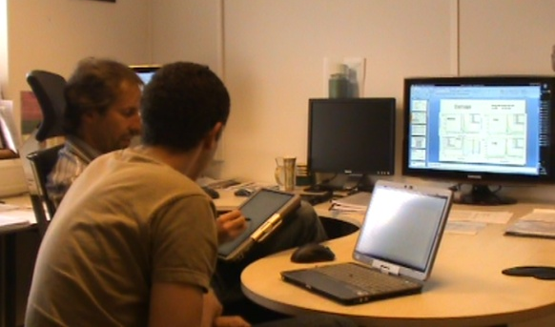
Figure 4 Viewing gesture on the tablet
Activity Scenario2. Set up 3. A group meeting is taking place between the research leader, first and second year PhDs students Anthony and George and post doc named Steven. John and George sit opposite sides of the desk, facing each other over the Surface. Steven and Anthony sit immediately to right of John (Figure 5.).
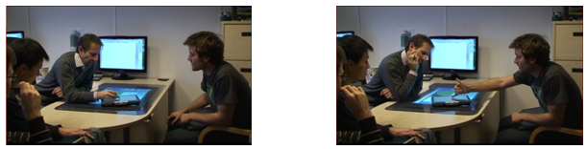
Figure 5 Content and interpretation converging on tablet
As in the previous example, John is sketching on the tablet, and periodically making gestures in conjunction with speech to explain his sketch and its relevance to the discussion at hand. Throughout, Steven and Anthony, sitting immediately to the right of John, view the sketches on the tablet itself, where they can see both sketch on gesture. Due to distance to his from and orientation to the tablet screen, George views the content on the monitor, occasionally looking to viewing John’s gestures over the tablet.
The meeting is approximately 30 minutes in, and for most of this time the content of John’s tablet has been displayed on the desk monitor, while the Surface has been used to display the main discussion slides. At this point, there is a failure with the wireless network (an occasional event) and the connection between the between the vertical display and the tablet is severed, meaning that the tablet becomes the sole embodiment of meeting notes and sketches. To compensate, John repositions the tablet, placing it on the Surface in such a way that all meeting member can view the content.
This movement of content to a more central and accessible position has an immediate impact upon the flow of the meeting. George’s closer proximity of the tablet enables him not only to see content and gesture from one site, but also to gesture to the content as well. Figures 4 and 5 show John motioning over part of the diagram with his stylus, to which George responds with accompanying gesture.
This scenario illustrates the consequences of spatial separation of content and interpretative gesture, and how repositioning of the tablet serves to bridge the gap. When George was only able to view John’s sketches on the shared monitor, John had to attend to the monitor to view the content and the tablet to view John’s interpretative action. However, the repositioned tablet plays the role of a central explanatory place where inscriptions and gestures are fluidly connected, thus eliminated John’s need to attend to two spatially separate parts of the meeting space. On the tablet’s repositioning, we see it become a site for gesture by more than one meeting member, which echos Hawkey (2005) findings and shows that proximity to content can expand user’s interpretive modes of action. For George, this repositioning of the tablet brought content closer, enabling him to make and view other’s interpretative moves. Thus the mobility of the tablet makes it particularly amenable to support explanation and collective interpretation of content and inscriptions.
4.2 Gesture across devices and binding of content
Frequently meeting discussion involved two resources displayed upon different devices. These resources are often meeting sketches and presentation slides, but can also involve academic papers, lab book pages or even raw experimental data. Meeting discussion often requires users to repeatedly cross reference between these resources, and our observations reveal the role of gesture in directing user attention within these encounters. We distinguish a particular order of gesture which helped facilitate this goal: binding gestures. Binding gestures serve to draw connection, or make explicit the connections between content, and are a key method through which users associated content and directed attention within multi-device environments.
Binding gestures manifested differently across the meeting setups, ranging across a spectrum from indirect and sequential, to direct and synchronous binding (summarised in Table 2). The following brief meeting scenarios provide examples of the different types of binding gesture observed within the study.
Activity Scenario 3. Set up 1. Indirect sequential binding. John and Peter are in a one to one meeting, and John has produced a sketch to describe a process Peter needs to run in his next experiment. On completing the sketch, John addresses Peter’s summary slides on the shared display, and uses the mouse to indirectly gestures to a graph which Peter has created. Immediately upon doing so, John points directly to a specific part of a sketch he has created on the tablet, illustrating a connection between the two.
This form of binding is indirect, as it involves indirect gesture to meeting content (although it does consist of direct pointing to the tablet). It is also sequential; the meeting leader points first with the mouse to the presentation and then directly to the tablet.
Activity Scenario 4. Set up 2. Direct sequential binding. As in the previous example, meeting members are discussing a summery prepared by a student, however, in this setup summary slides are displayed on the tabletop computer. John is resting his tablet on the tabletop computer and he and Zak, a post doc, are tracing their fingers over a graph displayed on the tabletop as they talk.
John begins to describe a solution and then starts to sketch it on the tablet, continuing to talk as he does so. Upon finishing the sketch he motions extensively over it as he explains it. He then makes a number of binding gestures between different parts of the summary and the sketch on the tablet. He does this by tracing over parts of the summary with his hands as he talks and then points to parts of the tablet sketch saying: ”this [pointing to the summary on the Surface] is this [pointing to part of the tablet sketch]” (Figure 6).
This differs from the previous binding example in that both parts of the binding gesture are made through direct deictic point.
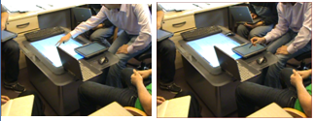
Figure 6 Direct sequential binding
Activity scenario 4. Set up 3. Direct synchronous binding. John is meeting with 2 PhD students and one post doc and the group are discussing a set of experimental results currently displayed on the tabletop. The results include an overexposed image taken during a recent experiment. John moves the tablet from his lap and positions it in close proximity to the image and begins to sketch on the tablet. On completing the sketch, he gestures over it with his stylus whilst explaining its meaning. Holding the stylus on a particular part of the sketch, he simultaneously places and holds his finger on the tabletop image, stating: ‘it depends if the camera saturates – you can be measuring here to here [indicating one part of his sketch] or here to here [indicating another part of his sketch]’ (Figure 7). This binding gesture helps John to elaborate the relationship between the image in the presentation and the sketched graph.
This differs to the previous binding example, in that the direct deictic pointing occurs synchronously across the two devices.
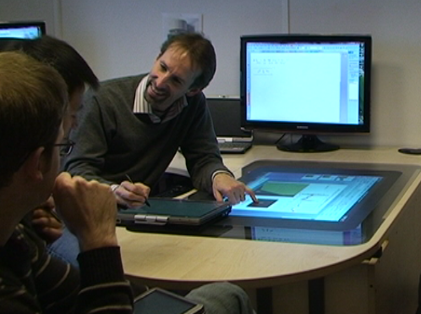 | Figure 7 Direct synchronous gesture
4.2.1 Binding on single devices
Activity scenario 5. Set up 2. Direct synchronous binding on a single device. John is meeting with 2 PhD students and one post doc, discussing a presentation slide on the Surface. Discussing a particular graph within the slide, the John simultaneously places the index fingers of both hands on two parts of the graph saying ‘there should be no overlap between this transition and this transition. What is the energy gap between these transitions?’ (Figure 8).
With this binding gesture John is doing two things. 1 illustrating a relationship between two different points in the image and 2. posing a questions about the relationship between the two points.
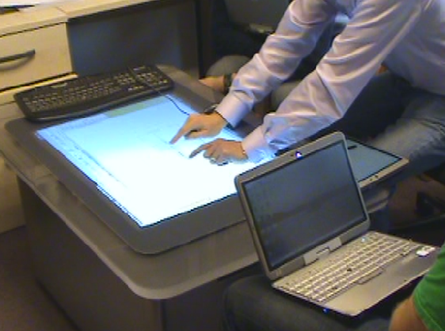
Figure 8 Direct synchronous binding on a single device
In each of the examples of binding gesture considered above, the meeting leader uses gesture to help make connections between meeting content, either upon a single device, or across two devices.
The ease with which binding gestures occur was strongly influenced by the technological setup of the meeting. In meeting setup 1, binding occurred through two different modes of gesture: indirect gesturing to content via the mouse, followed by the direct deictic gesture to the tablet. Compared to later meeting setups this appeared cumbersome, not only due to the different modes of gesture, but because this gesturing to content directed attention across a wide visual frame, from the vertical monitor to the horizontal tablet and back again. In contrast, in meeting setups 2 and 3, both tabletop and tablet were on the same horizontal plane when binding occurred. This appears to increase the ease with which binding gestures coudl be performed between two devices. Furthermore, the spatial flexibility of the tablet appeared to play a significant role, enabling the inscription space to be brought into close proximity with the meeting artefact which inspired it, and consequently increasing the ease of binding gestures. Finally, the increases in deictic gestures we observed in the setups 2 and 3 as a result of the introduction of the tabletop computer extended the gestural language within the meeting space and providing the scope for such gestures to emerge.
Table 2 Observed binding gestures
Set up | Type of binding | What happens | Form of gesture | Function of gesture
1 | Indirect sequential binding | Binding between summary on monitor and sketch on tablet | Mouse point to summary, then direct point to sketch | Associate graph and sketch
2 | Direct sequential binding | Binding between sketch on tablet and summary on Surface | Direct point to sketch, then direct point to summary | Associate graph and sketch – explain graph by way of sketch
3 | Direct synchronous binding | Binding between sketch on tablet and summary of Surface | Synchronous direct point to tablet and Surface | Associate sketch and summary image – explain sketch with reference to image
2 | Direct synchronous binding on single device | ‘Binding’ between two different parts of the summary displayed on surface | Synchronous pointing to two points on the surface | To explain the relationship between 2 elements of the summary

7 DESIGN GUIDELINES
We propose that design of meeting spaces and systems should seek to support binding and inscription, align content and gestural interpretation, and distinguish interpretation and gesture.
7.1 Align content and interpretation
Where appropriate, content and gestural interpretation should be brought into alignment, to maximise binding opportunities and minimise bifurcations of user attention. Partly, this may be achieved through the careful alignment of the meeting space to ensure that screens displaying related material are within close proximity. This will serve to reduce splits within the content sphere which may lead to bifurcation and also increase the opportunities for binding between content.
Hawkey et al. (2005) highlight the significance proximity and size of display for collaborative settings, factors which are also important in the alignment of content and interpretation spheres. Proximity tends to bring the content and interpretative gesture together: the closer users are to displays, the more interpretative opportunities arise, and the better these actions can be viewed by other meeting members. Large screens are well suited for this, and Rogers and Lindley have found that horizontal surfaces afford most gesture.
However, in meeting space it is not always possible or appropriate to view content in this way. Especially in the larger groups, it may be necessary for one group member to ‘drive’ a large shared display, in order to provide adequate visual access to the same content. In the meeting space considered in this study, notes and inscriptions which are projected to a shared display, but in other contexts, it may be presentation displayed on a large screen, or supporting documents. Interpretation of such content may involve gesture, or pointing to particular areas of the screen which would be lost, or have to be translated into other forms such as speech if projected. For projector displays, laser pointer may be used, but have been shown not to be accurate, and mouse gestures are cumbersome when compared to natural gestures (Plaue et al). CSCW has developed techniques to ‘project’ gesture into remote collaboration spaces, and similar techniques could be developed to detect user gesture on personal device transfer them onto shared displays within collocated space. Projecting gestures would leverage the user’s fluid and natural interpretative gesture and minimise bifurcation of user attention between two meeting areas.
7.2 Support binding and inscription
The tablet supported well many aspects of inscription. Its mobility afforded easy orientation and reorientation to content in different areas of the meeting space or on the Surface display. This aided cross referencing between content and inscription during its creation, and binding afterwards. Proximity of inscription space to content is a key requirement. Within interactive tabletops or within ubiquitous computing environments, inscription spaces should be available everywhere and easily accessible. The inscription space should be a resizable, to support different types and style of inscription. Inscription spaces should be available for any element of content, and inscriptions associated with the content should be easily retrievable. Furthermore adjacency within the same plane appeared also to help facilitate binding, and should also be supported.

7.3 Distinguish interpretative gesture from input gesture
Gesture on the tabletops has significant meaning and represents a central aspect of the sphere or interpretation. Interactive tabletops should enable this activity by either locking content so that touch does not disturb it, or developing methods for distinguishing between ‘interpretative touch’ and touch as input. The space of interpretative gesture extends above the Surface. This needs to be taken into account in the design of ‘continuous interaction spaces’[7] and 3D gestures languages above the tabletops.
8. CONCLUSION AND FUTURE WORK
We have explored the introduction of a tabletop computer to a meeting space and highlighted its impact upon the activities conducted within. This has enabled us to illustrate the role of binding gestures in directing attention to single devices, and heterogeneous content across multiple devices. While the gestures we observed played a role in the interpretation and explication of content within this environment, we know little about the existence of binding gestures in other domains. Consequently, we plan to conduct follow up studies in comparative multi-device meeting environments across a broad range of domains to test the wider applicability of the findings presented in this paper.

REFERENCES
- Cortina, L. J., Zhao, Q., Cobb, P., McClain, K. Supporting students’ reasoning with inscriptions, in Proceedings of 6th international conference of learning science, 2004, 124 – 149
- Goodwin, C. Pointing as Situated Practice. In S. Kito, Pointing: Where Language, Culture, and Cognition Meet, Mahwah, NJ: Lawrence Erlbaum Associates, Inc., 2003. 217--242.
- Ha, V., Inkpen, M. K., --- Direct interntions: the effects of input devices on collaboration around a tabletop display IEEE 2006 – full ref needed
- Hawkey, M.,… The Proximity Factor: Impact of Distance on Co-located Collaboration 2005 full ref needed
- Hadar, U., and Butterworth, B. Iconic gestures, imagery, and word retrieval in speech. 1997 Semiotica 115, 15. 147-172
- Latour, Bruno (1987). Science In Action: How to Follow Scientists and Engineers Through Society, Harvard University Press, Cambridge Mass., USA
- Kirk, d., Crabtree, A., Rodden, T. Ways of the hands, Proceedings of the ninth conference on European Conference on Computer Supported Cooperative Work, p.1-21, September 18-22, 2005, Paris, France
- Kraut, R.E., Fussell, S.R., and Siegel, J. 2003. Visual Informationas a Conversational Resource in Collaborative Physical Tasks. Human-Computer Interaction 18:13-49.
- Nobert, S. et al. i-LAND: an interactive landscape for creativity and innovation (1999) CHI – need full ref
- Marquardt, N., Jota, R., Greenberg, S., Jorge, J.A. (2009) The Continuous Interaction Space: Integrating Gestures Above a Surface with Direct Touch. Report 2009-925-04, Department of Computer Science, University of Calgary
- Mathilde M. Bekker , Judith S. Olson , Gary M. Olson, Analysis of gestures in face-to-face design teams provides guidance for how to use groupware in design, Proceedings of the conference on Designing interactive systems: processes, practices, methods, & techniques, p.157-166, August 23-25, 1995, Ann Arbor, Michigan, United States
- Medina, R., Suthers, D., & Vatrapu, R. (2009). Inscriptions becoming representations. Proceedings of the 9th internation conference on Computer Supported Collaborative Learning 2009, 142 0 149
- McNeill, D. (1992). Hand and mind: What gestures reveal about thought. Chicago: University of Chicago Press.
- Olsen, J., & Olsen, G. (2004) Why distances matters. Human Computer Interaction, 15, 139-179
- Piper, A. M., Hollan, J, D. Supporting medical conversations between deaf and hearing individuals with tabletop displays, Proceedings of the ACM 2008 conference on Computer supported cooperative work, November 08-12, 2008, San Diego, CA, USA
- Rogers, Y., Hazlewood, M., Blevis, E. Lim, Y. Finger talk: collaborative decision-making using talk and fingertip interaction around a tabletop display, CHI '04 extended abstracts on Human factors in computing systems, April 24-29, 2004, Vienna, Austria
- Rogers, Y. and Lindley, S.E. (2004). Collaborating around vertical and horizontal large interactive displays: Which way is best? Interacting with Computers, 16, 6, 1133-1152.
- Sellen and Harper. The myth of the paperless office 2002 full reference needed
- Streeck, J., & Kallmeyer, W. Interaction by inscription. Journal of Pragmatics, 33(4), 2004, 465

